|  |  |  |  |  |
| --- | --- | --- | --- | --- |
| **Reading Time**: An initial **2 minutes** to view **BOTH** sections | **MATHEMATICS METHODS : UNITS 3 & 4, 2022**  Test 4 – (10%) 4.1.9 – 4.1.14, 4.2.1 – 4.2.7, 4.3.1 – 4.3.3 | | |  |
| **Time Allowed**  26 minutes | | **First Name Surname** | **Marks**  28 marks | |

**Circle your Teacher’s Name:** Mrs Alvaro Mrs Bestall Mrs Fraser-Jones Mr Gibbon/Luzuk Mrs Greenaway Mr Koulianos Mr Luzuk Mrs Murray Mr Tanday

|  |  |
| --- | --- |
| **Assessment Conditions: *(N.B. Sufficient working out must be shown to gain full marks)***   |  | | --- | | * Calculators: Not Allowed * Formula Sheet: Provided * Notes: Not Allowed | |

**PART A – CALCULATOR FREE**

Question 1 [1,2,3 - 6 marks]

Differentiate the following. Do not simplify:

$\ln\left(\sin{x}\right)$

${\left[\ln\left(3x\right)\right]}^{2}$

$$\left(c\right) \ln\left(\frac{{\left(3x+1\right)}^{2}}{x-2}\right)$$

Question 2 [2,3,2 - 7 marks]

As part of a local arts festival, an artist plans to create an installation in which a concealed water cannon blasts a stream of water into the air for a few seconds at random intervals. The lengths of the intervals between each firing of the cannon can be modelled by the uniformly distributed random variable $T,$ where $3≤t≤14$ minutes.

1. Sketch the probability density function $f(t)$ for the interval between firings on the axes below:

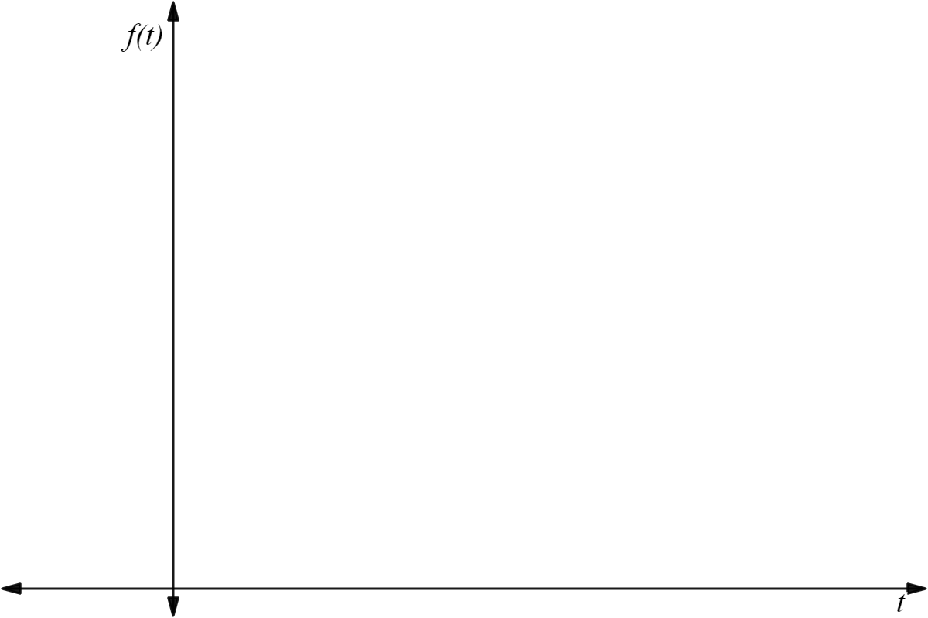

1. Determine the probability that a randomly chosen interval between firings is:
   1. at least seven minutes
   2. at least six minutes given that it is less than ten minutes.
2. Determine the value of $t$ for which $P\left(T<t\right)=P(T>4t)$

Question 3 [2, 4 - 6 marks]

Determine:

$$\left(a\right) \int{\frac{3x}{5x^{2}-2}.dx}$$

(express answer as a single logarithm in exact form)

$$\left(b\right) \int_{-2}^{-1}{\frac{8x-6}{2x^{2}-3x}.dx}$$

Question 4 [2,2,3,2 - 9 marks]

The continuous random variable $X$ has probability density function:

$$f(x)=\left\{\begin{aligned}\frac{x^{2}}{3}, &-1≤x≤2 \\ 0, &elsewhere\end{aligned}\right.$$

1. Determine $E(X)$
2. The variance of $X, Var\left(X\right)$ is $\frac{51}{80}.$ Determine:
$E\left(8X+2\right)$

$Var(8X+2)$

3. Determine the cumulative distribution function $F\left(x\right).$
4. Calculate $P(1<X<2)$

**End of section**

|  |  |  |  |  |
| --- | --- | --- | --- | --- |
| **Reading Time**: An initial **2 minutes** to view **BOTH** sections | **MATHEMATICS METHODS : UNITS 3 & 4, 2022**  Test 4 – (10%) 4.1.9 – 4.1.14, 4.2.1 – 4.2.7, 4.3.1 – 4.3.3 | | |  |
| **Time Allowed**  24 minutes | | **First Name Surname** | **Marks**  24 marks | |

**Circle your Teacher’s Name:** Mrs Alvaro Mrs Bestall Mrs Fraser-Jones Mr Gibbon/Luzuk Mrs Greenaway Mr Koulianos Mr Luzuk Mrs Murray Mr Tanday

|  |  |
| --- | --- |
| **Assessment Conditions: *(N.B. Sufficient working out must be shown to gain full marks)***   |  | | --- | | * Calculators: Allowed * Formula Sheet: Provided * Notes: Not Allowed | |

**PART B – CALCULATOR ALLOWED**

Question 1 [2,2,3 – 7 marks]

Tubs of Peter’s No Sugar Added ice-cream are labelled $750$ g Peter’s know that customers will switch to a competitor’s brand if they suffer bad publicity. Tests on $500$ tubs of ice-cream show that they are normally distributed with a mean mass of $754$ g and a standard deviation of $4.2$ g.

1. Find the percentage of tubs that are over the labelled mass.
2. DIABETICFOODS order $10$ crates of ice-cream, each with $150$ tubs. How many tubs sent to DIABETICFOODS would be expected to be less than the labelled mass?
3. Peter’s decide they need to improve the accuracy of their mass balances by recalibrating the machine. What will the mean mass (to the nearest gram) need to be so that less than $1\%$ of tubs are under the labelled mass?

Question 2 [2,2 – 4 marks]

For each of the following scenarios, comment on whether the sample selected is likely to be representative of the population. Justify your answer.

1. A political scientist is interested in determining the likely outcome of an election. She contacts registered voters via phone by calling random landline numbers in the electorate during weekday business hours (9am –5pm).
2. A zoologist wishes to determine the average mass of bare-nosed wombats. He selects a sample of bare-nosed wombats in a nearby rescue shelter and determines the average mass.

Question 3 [3,1,2 – 6 marks]

A personal trainer organizes a workout program that involves running 15 minutes on a straight track. The workout involves a run at a constant $6.5$ km/h for three minutes and then the speed, $s\left(t\right),$ is defined by the equation:

$$s\left(t\right)=6-\frac{\ln\left(t-2.99\right)}{t^{2}} km/h$$

1. Sketch the graph of the speed during this run versus time on the axes below:

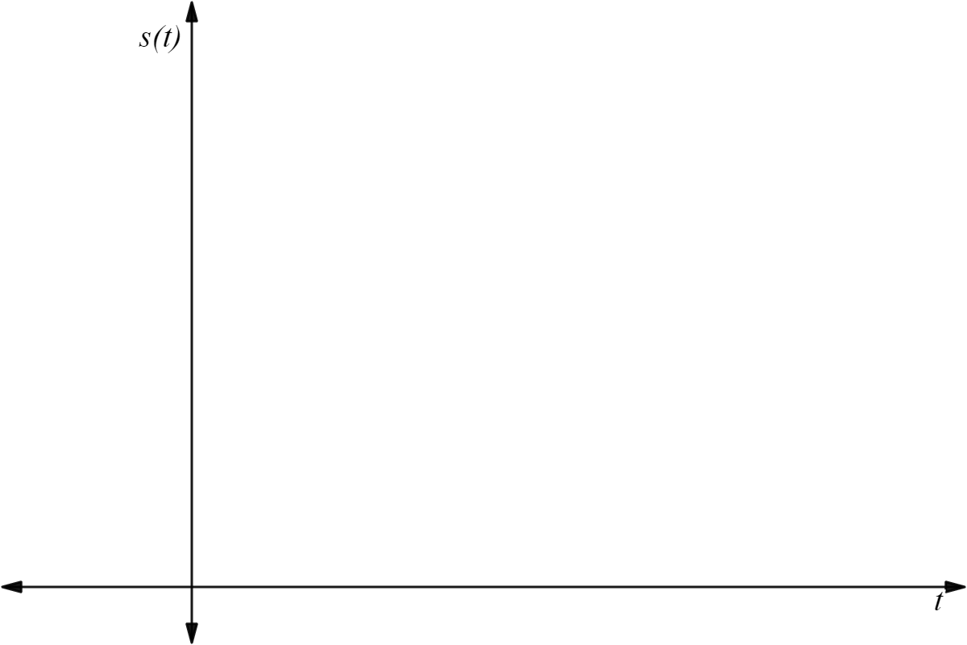

1. At what time is the speed of the runner $6$ km/h?
2. At what time during the run is acceleration zero?

Question 4 [4,3 – 7 marks]

The continuous random variable $X$ has probability density function:

$$f(x)=\left\{\begin{aligned}ax+b, &1≤x≤3 \\ 0, &elsewhere\end{aligned}\right.$$

It is also known that $P\left(X<2\right)=5/8$

1. Determine the value of the constants $a$ and $b$.
2. Hence, determine the expected value and variance of $X.$

**End of section**